Care Coordination (CC) Standardized Episodes of Care (SEOC)

Software Version 1.0.04.1

User Guide



September 2018

Department of Veterans Affairs

Office of Information and Technology (OI&T)

Revision History

NOTE: The revision history cycle begins once changes or enhancements are requested after the document has been baselined.

|  |  |  |  |
| --- | --- | --- | --- |
| Date | Revision | Description | Author |
| 09/25/18 | 1.0 | Initial draft for Software Version 1.0.04.1 | AbleVets |

**Artifact Rationale**

Per the Veteran-focused Integrated Process (VIP) Guide, the User’s Guide is required to be completed prior to Critical Decision Point #2 (CD2), with the expectation that it will be updated as needed. A User Guide is a technical communication document intended to give assistance to people using a particular system, such as VistA end users. It is usually written by a technical writer, although it can also be written by programmers, product or project managers, or other technical staff. Most user guides contain both a written guide and the associated images. In the case of computer applications, it is usual to include screenshots of the human-machine interfaces, and hardware manuals often include clear, simplified diagrams. The language used is matched to the intended audience, with jargon kept to a minimum or explained thoroughly. The User Guide is a mandatory, build-level document, and should be updated to reflect the contents of the most recently deployed build. The sections documented herein are required if applicable to your product.

**Table of Contents**

1. Introduction 1

1.1. Purpose 1

1.2. Document Orientation 1

1.2.1. Organization of the Manual 1

1.2.2. Assumptions 2

1.2.3. Coordination 2

1.2.4. Disclaimers 3

1.2.4.1. Software Disclaimer 3

1.2.4.2. Documentation Disclaimer 3

1.2.5. Documentation Conventions 3

1.2.6. References and Resources 3

1.3. National Service Desk and Organizational Contacts 3

2. System Summary 3

2.1. System Configuration 4

2.2. Data Flows 5

2.3. User Access Levels 5

2.4. Continuity of Operation 6

3. Getting Started 6

3.1. Logging On 6

3.2. System Menu 7

3.3. Changing User ID and Password 7

3.4. Exit System 7

4. Using the Software 8

4.1. View SEOCs 8

4.1.1. View a Selected SEOC 8

4.1.2. Search for a SEOC by Name 10

4.1.3. Filter SEOCs by Status 10

4.1.4. Discontinue a SEOC 11

4.1.5. Print a SEOC 12

4.2. Create a Draft SEOC 13

4.2.1. Edit a Draft SEOC 19

4.2.2. Activate a Draft SEOC 20

4.2.3. Delete a Draft SEOC 21

4.3. Pending Revisions 22

4.3.1. Create a Pending Revision 22

4.3.2. Activate a Pending Revision 25

4.4. Payable Service List 27

4.4.1. View Payable Services 27

4.4.2. Delete Payable Service 27

5. Troubleshooting 28

6. Acronyms and Abbreviations 28

List of Figures

Figure 1: Overview of SEOC System 4

Figure 2: SEOC Data Flow Diagram 5

Figure 3: VA Single Sign-On for SEOC 6

Figure 4: Standardized Episodes of Care Home Page 7

Figure 5: Standardized Episode of Care – Provider Information 9

Figure 6: SEOC Search Field 10

Figure 7: Search SEOC Results 10

Figure 8: Filter Status By Menu Options 11

Figure 9: Discontinue SEOC Confirmation 11

Figure 10: Discontinue Status 12

Figure 11: Printed SEOC Window 13

Figure 12: Draft SEOC: Name 14

Figure 13: Draft SEOC Details 15

Figure 14: Draft SEOC: Payable Services 16

Figure 15: Draft SEOC: Add Payable Service 17

Figure 16: Draft SEOC: Add Billing Code 18

Figure 17: Duplicate Billing Code Message 19

Figure 18: Draft SEOC View 19

Figure 19: SEOC Activation Confirmation 20

Figure 20: Activation Status 21

Figure 21: Confirm Deletion 21

Figure 22: Pending Revision: Name 22

Figure 23: Pending Revision: Details 23

Figure 24: Pending Revision: Payable Services 24

Figure 25: Pending Revision Status 25

Figure 26: Pending Revision Displayed in SEOC List 25

Figure 27: Pending Revision Activation Confirmation Message 26

Figure 28: Active Status 26

Figure 29: Standardized Episode of Care – Payable Services 27

Figure 30: Payable Service Confirm Deletion 28

# Introduction

The Care Coordination (CC) Standardized Episodes of Care (SEOC) is a reference database for managing care bundles for use by Veterans Information Systems and Technology Architecture (VistA) and other Department of Veterans Affairs (VA) systems. Services are grouped together within the SEOC system into bundles so that clinicians can add these bundles to patients consult records in a standardized fashion, reducing the amount of time spent manually entering consult instructions, and providing uniformity among the patient records and across facilities for how patient care is prescribed for similar complaints.

These bundles group together one or more services that are preselected for different specialties to be added to the consult records. In addition, the clinician is provided with information regarding prescribing rules and preauthorization requirements, so they can make the most informed decisions regarding patient care.

Additionally, SEOC data will be accessible outside of the VistA/Computerized Patient Record System (CPRS) system so that users of downstream applications will be accessing the centralized data, and SEOC descriptions, reducing the chances of disconnects.

## Purpose

The purpose of this document is to provide instruction for utilizing the Consult Toolbox to standardize and streamline consult management for Community Care.

## Document Orientation

The *Care Coordination (CC) Standard Episodes of Care (SEOC) User Guide* will provide explanations of each screen and of all user interface options within the context of an easy to understand demonstration data scenario.

This document is also designed to provide the user with screen-by-screen “how to” information on the usage of CC SEOC.

### Organization of the Manual

**Section 1: Introduction**

The Introduction section provides the purpose of this manual, an overview of the SEOC software, an overview of the software used, project references, contact information for the user to seek additional information, and an acronyms and abbreviations list for this manual.

**Section 2: System Summary**

The System Summary section provides a graphical representation of the equipment, communication, and networks used by the system, user access levels, how the software will be accessed, and contingencies and alternative modes of operation.

**Section 3: Getting Started**

Information for the Getting Started section provides a general walk-through of the system from initiation through exit, enabling the user to understand the sequence and flow of the system.

**Section 4: Using the Software**

This section gives the user the “how to” information to use SEOC, including many step-by-step procedures.

**Section 5: Troubleshooting**

This section provides troubleshooting for the SEOC user.

**Section 6: Acronyms and Abbreviations**

This section provides a list of acronyms and abbreviations found in this document.

### Assumptions

This guide was written with the following assumed experience/skills of the audience:

* The SEOC user has basic knowledge of the SEOC system (such as the use of commands, menu options, and navigation tools).
* The SEOC user has been provided the appropriate active roles, menus, and security keys required for the SEOC User Interface (UI), as defined below in User Roles.
* The SEOC user is using SEOC to perform their daily consult creation workflow and perform the required SEOC functions.
* The SEOC user has validated access to the SEOC UI.
* The SEOC user has been provided training on the SEOC UI and has reviewed the User Guide.
* SEOC Content Authors: The SEOC Content Authors are responsible for creating and update the content within the SEOC repository using the SEOC UI. These users are required to VA access rights and privileges and will sign on to the SEOC application using their SSOI credentials (typically their PIV and access code).
* CPRS Clinicians that are responsible for documenting patient consult records. These clinicians utilize the SEOC content as part of their daily consult creation workflow such that they will add a SEOC bundle to the patient consult record which will provide for a standardized documentation and care plan approach across the VA for these consults.

### Coordination

One Consult - Consult Toolbox 1.9.02 and above and the HealthShare Referral Manager (HSRM) depend on the availability of the SEOC System. Consult Toolbox 1.9.02 requires active SEOCs whereas HSRM requires active and discontinued SEOCs. Coordination between the One Consult – Consult Toolbox, HSRM, and SEOC team is necessary with any updates to SEOC.

### Disclaimers

#### Software Disclaimer

This software was developed at the Department of Veterans Affairs (VA) by employees of the Federal Government in the course of their official duties. Pursuant to title 17 Section 105 of the United States Code this software is not subject to copyright protection and is in the public domain. VA assumes no responsibility whatsoever for its use by other parties, and makes no guarantees, expressed or implied, about its quality, reliability, or any other characteristic. We would appreciate acknowledgement if the software is used. This software can be redistributed and/or modified freely provided that any derivative works bear some notice that they are derived from it, and any modified versions bear some notice that they have been modified.

#### Documentation Disclaimer

The appearance of external hyperlink references in this manual does not constitute endorsement by the Department of Veterans Affairs (VA) of this Web site or the information, products, or services contained therein. The VA does not exercise any editorial control over the information you may find at these locations. Such links are provided and are consistent with the stated purpose of the VA.

### Documentation Conventions

This manual uses several methods to highlight different aspects of the material.

Table 1. Documentation Symbols and Descriptions

|  |  |
| --- | --- |
| Symbol | Description |
| Triangle with an exclamation point (!) inside to indicate caution for the reader to take special notice of critical information. | **CAUTION:** Used to caution the reader to take special notice of critical information. |

1. Notes are used to inform the reader of general information including references to additional reading material.

### References and Resources

Readers who wish to learn more about CPRS and CC SEOC should consult the following:

## National Service Desk and Organizational Contacts

For issues related to the CC SEOC that cannot be resolved by this manual or the site administrator, please contact the National Service Desk at 855-NSD-HELP (673-4357).

# System Summary

There was an immediate need to provide clinicians the ability to quickly and consistently add care bundles to a patient’s consult record within VistA. SEOC provides this feature for a higher level of uniformity in patient care, easier access to appropriate services, based on initial diagnoses, and the ability to better control care costs. SEOC allows clinicians to enhance the coordination of care for the Veteran.

The system contains SEOCs, or care bundles, that clinicians or other designated individuals can assign to VA patients. These bundles allow for the consistent use of procedures when certain conditions are diagnosed. This consistency allows the VA to effectively manage patient care and provides easier traceability.

## System Configuration

The SEOC System is designed to be a simple reference database with a supporting SEOC API and User Interface (UI) layer. The SEOC system comprises three application tiers as shown below.

Figure 1: Overview of SEOC System

SEOC Figure 1. 
Diagram depicting the 3 tiers of the SEOC system. 

The first tier is the Data Tier. This tier contains SEOC data. SEOC uses Microsoft Structured Query Language (SQL) Server is the database. SEOC data consists of reference data, such as SEOC name, associated procedures, associated Current Procedural Terminology (CPT) codes, procedure durations, etc. Additionally, user role information is maintained within the tables, but no passwords or other credentials are stored. No PHI or PII is stored in the database. SEOC data is associated with patient data in the VistA consult record.

The second tier is the Abstraction Tier. This tier acts as the data broker for the SEOC system. It is a REST Application Programming Interface (API), built as a microservice hosted on container infrastructure (Docker Container). The API itself is built on the Spring MVC framework. The API receives web API calls that are forwarded to the database appropriately. Consuming applications are able to query the SEOC system through the SEOC REST API but will not be able to perform updated operations. The SEOC UI uses certificates to authenticate with the SEOC REST API to allow data modification within the SEOC system by authenticated users. Users are authenticated using SSOI. Additionally, a VistA/MUMPS patch is created to insert the SEOC associations into File # 123.

The third and final tier is the Presentation Tier. This tier consists of the SEOC UI, which provides a user interface for approved, authenticated users to maintain the SEOC collection. This application is a web application built as a microservice hosted on container infrastructure (Docker Container). The UI is built using the React.js JavaScript framework for web applications.

## Data Flows

Figure 2: SEOC Data Flow Diagram

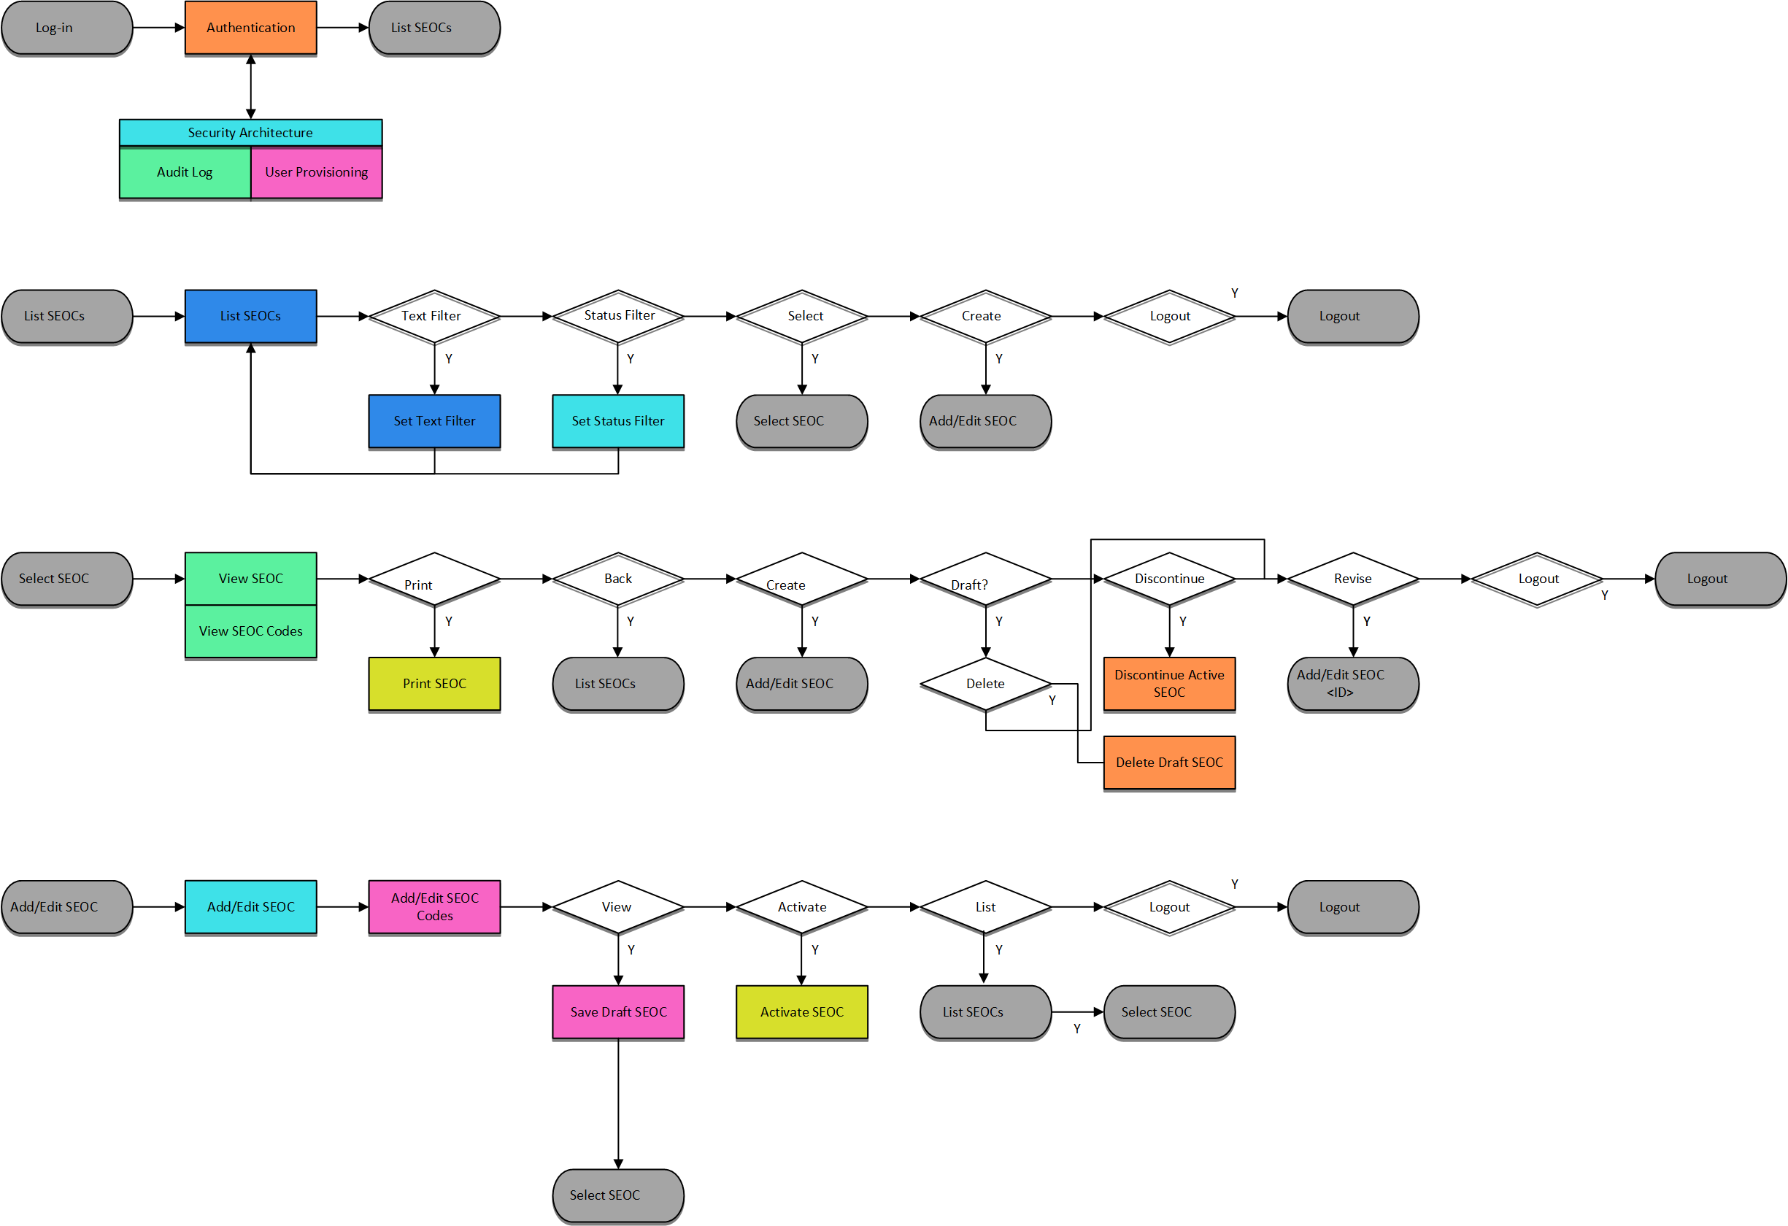

## User Access Levels

SEOC user profiles comprise of the following “types of users”:

* SEOC Content Authors: The SEOC Content Authors are responsible for creating and update the content within the SEOC repository using the SEOC UI. These users are required to VA access rights and privileges and will sign on to the SEOC application using their SSOI credentials (typically their PIV and access code).
* CPRS Clinicians that are responsible for documenting patient consult records. These clinicians utilize the SEOC content as part of their daily consult creation workflow such that they will add a SEOC bundle to the patient consult record which will provide for a standardized documentation and care plan approach across the VA for these consults.
* SEOC data is also accessible to other external consumers in the future (in addition to CPRS users). The SEOC API is a RESTFul API that other (to be determined) users will have access to use.

## Continuity of Operation

The SEOC system is maintained by Enterprise Operations (EO). The continuity of operations is managed by EO.

# Getting Started

This section provides a general walkthrough of CC SEOC from initiation through exit.

## Logging On

CC SEOC is accessed using the VA Single Sign-On Internal (SSOi) log in using the following URL: <https://seoc.va.gov/>

Figure 3: VA Single Sign-On for SEOC

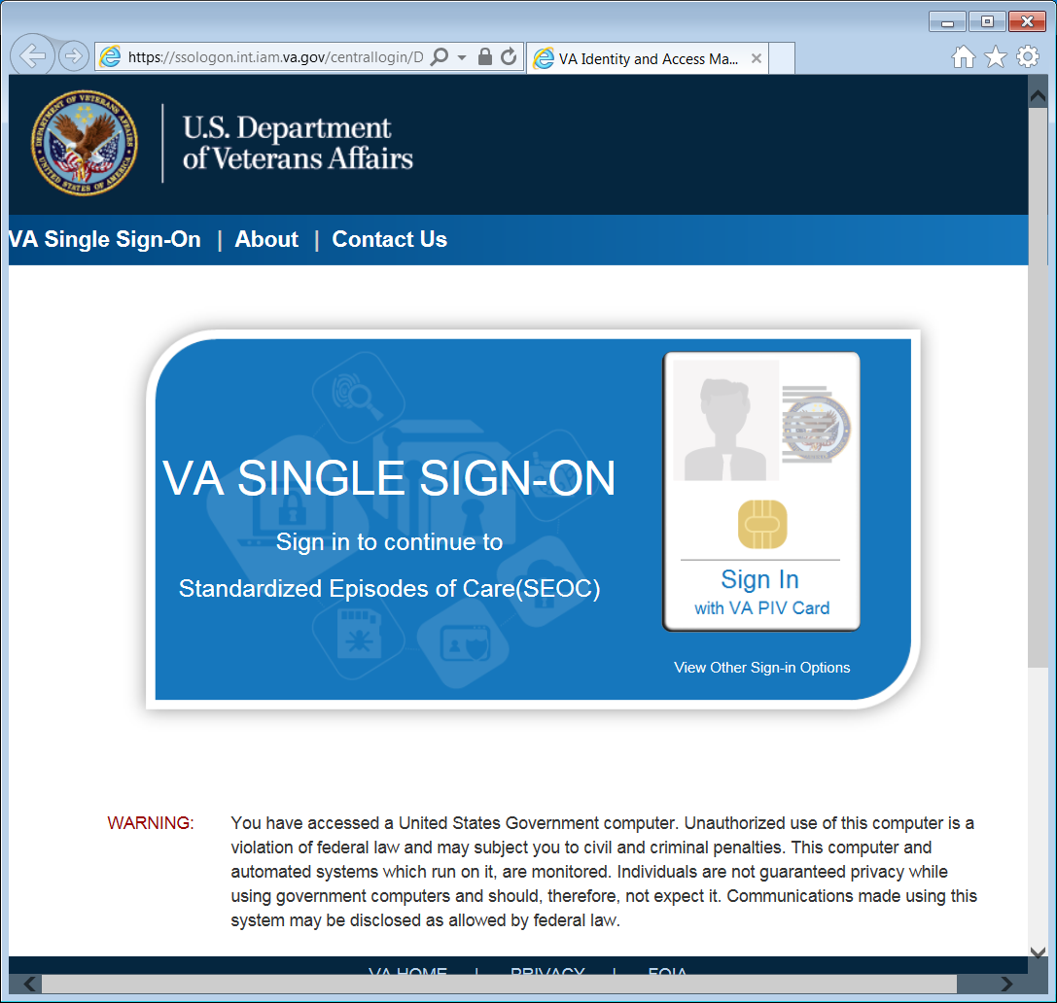

1. After 15 minutes of inactivity the system will automatically log you out.

## System Menu

The Standardized Episodes of Care home page offers four features: search for a SEOC by name, filter the list of SEOCs by status, View Selected SEOC, and Draft New SEOC.

Figure 4: Standardized Episodes of Care Home Page

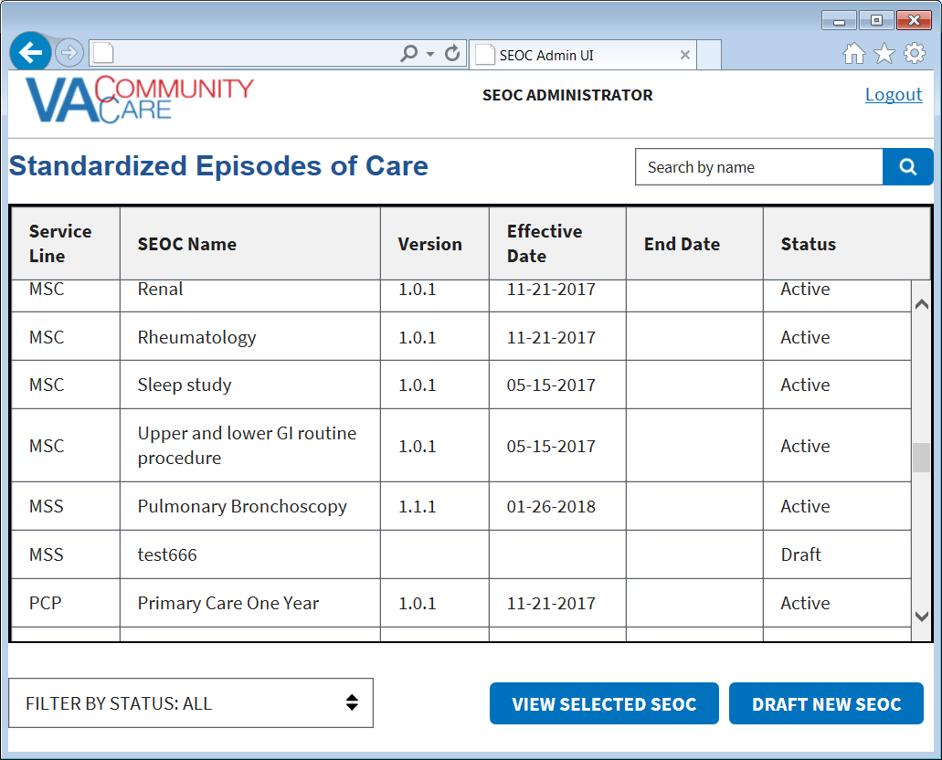

## Changing User ID and Password

If you need to change your user password, you will need to contact your local PIV office.

## Exit System

If you are finished working, log out of VA Single Sign-On and close any secure sessions that may still be open by clicking the **Logout** button.

# Using the Software

The CC SEOC provides user functionality for the following items:

* **Viewing SEOCs**
* **View a Selected SEOC**
* **Search for a SEOC by Name**
* **Filter SEOCs by Status**
* **Discontinue a SEOC**
* **Print a SEOC**
* **Create a Draft SEOC**
* **Edit a Draft SEOC**
* **Activate a Draft SEOC**
* **Delete a Draft SEOC**
* **Create a Pending Revision**
* **Payable Service List**
* **View Payable Services**
* **Delete Payable Services**

## View SEOCs

### View a Selected SEOC

To view a SEOC from the SEOC list, follow the steps listed below:

1. From the CC SEOC home page, select the SEOC you would like to view.
2. Click **View Selected SE**OC. The **Standardized Episode of Care – Provider Information** page displays.

Figure 5: Standardized Episode of Care – Provider Information

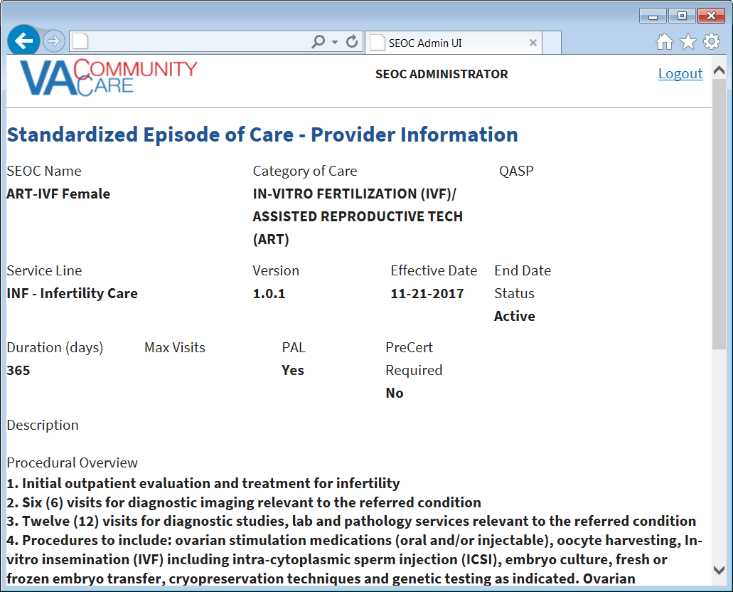

1. The QASP field is displayed on the screen, however, additional options for data entry will be available with the next release of the software

### Search for a SEOC by Name

To search for a SEOC, follow the steps listed below:

1. From the CC SEOC home page, enter the name of the SEOC in the search field.

Figure 6: SEOC Search Field

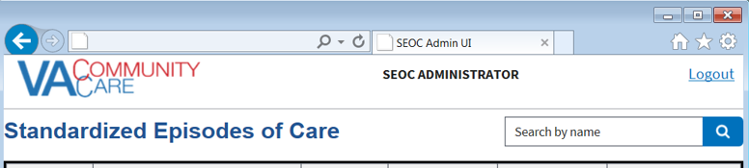

1. Click the **Search** button. The **Search SEOC Results** displays.

Figure 7: Search SEOC Results

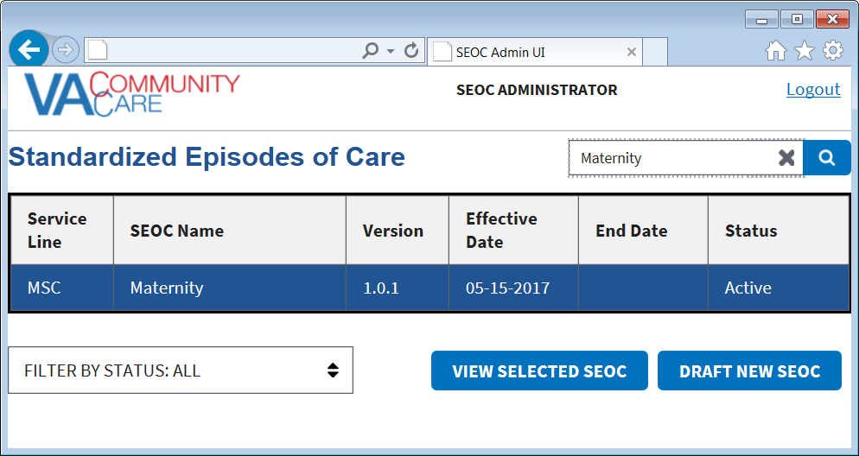

### Filter SEOCs by Status

To filter the list of SEOCs by status, follow the steps listed below:

1. From the CC SEOC home page, select **Filter By Status** menu.

Figure 8: Filter Status By Menu Options

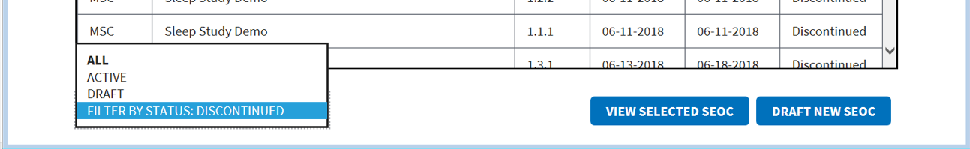

1. From the list of options select to filter by: **All**, **Active**, **Draft**, or **Discontinued**.

### Discontinue a SEOC

To discontinue a selected Active SEOC, follow the steps listed below:

1. From the CC SEOC home page, select the SEOC you would like to discontinue.
2. Click **View Selected SE**OC, the **Standardized Episode of Care – Provider Information** page displays.
3. Click **Discontinue SEOC**. The discontinue SEOC confirmation dialog box displays.

Figure 9: Discontinue SEOC Confirmation



1. Click **Confirm Discontinue**. The **Standardized Episode of Care – Provider Information** page displays with the updated status of the SEOC.

Figure 10: Discontinue Status

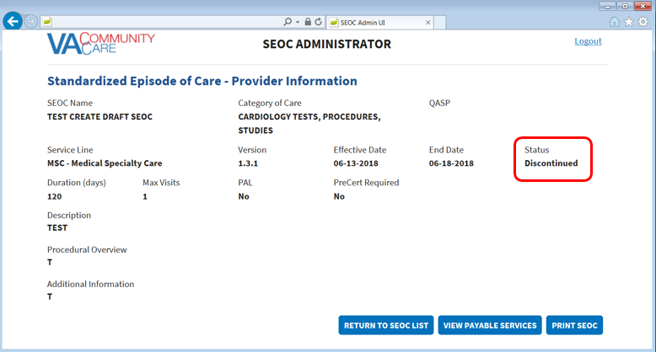

### Print a SEOC

To print a SEOC, follow the steps listed below:

1. From the CC SEOC home page, select the SEOC you would like to print.
2. Click **View Selected SE**OC, the **Standardized Episode of Care – Provider Information** page displays.
3. Click **Print SEOC**. The printed SEOC will display in another window. Print or save using local browser capabilities.

Figure 11: Printed SEOC Window

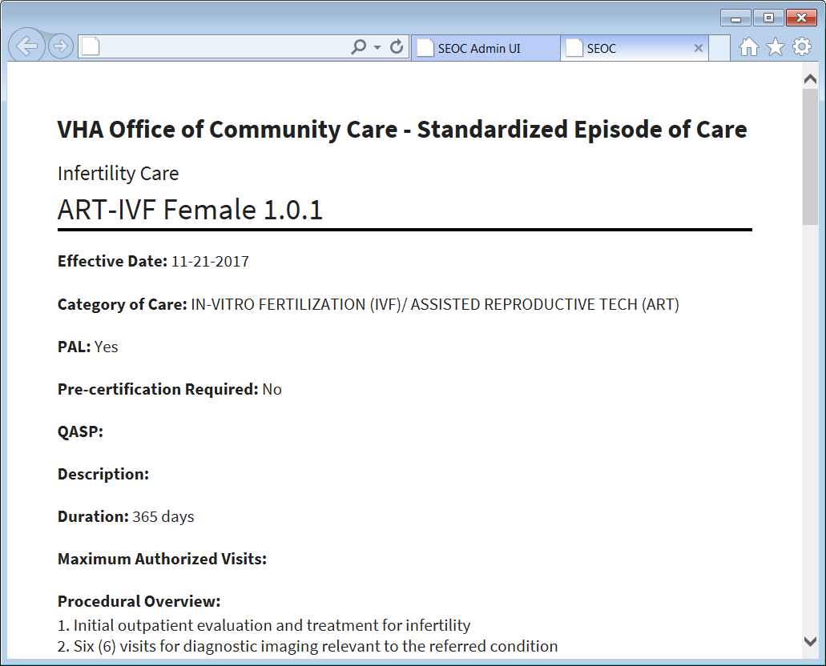

## Create a Draft SEOC

To draft a new SEOC, follow the steps listed below:

1. From the CC SEOC home page, click **Draft New SEOC**. The **Draft SEOC: Name** window displays.

Figure 12: Draft SEOC: Name

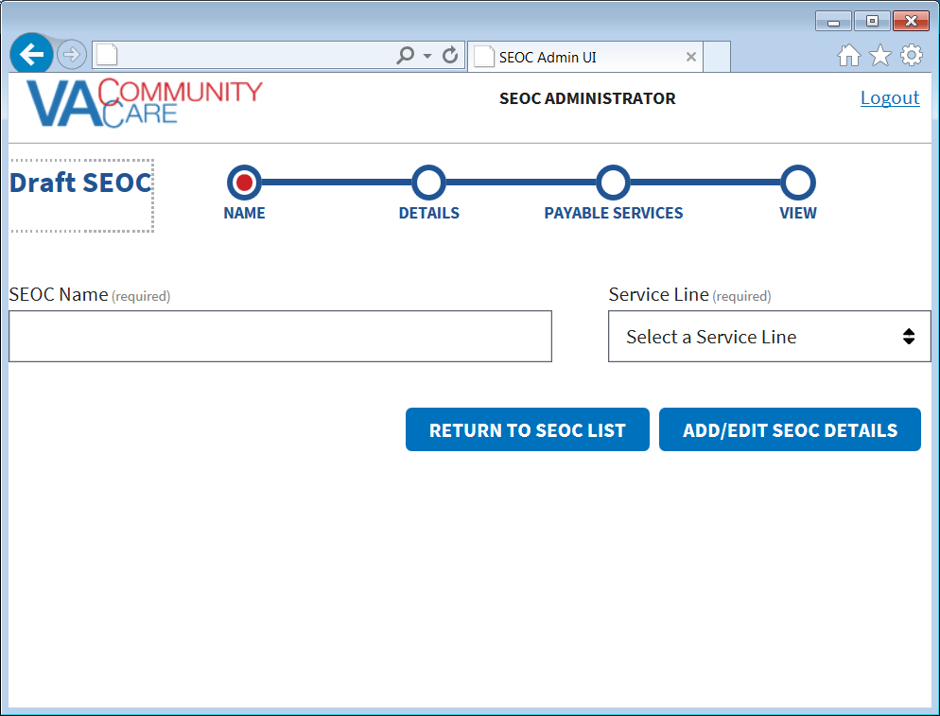

1. In the **SEOC Name** field, enter the name for the new SEOC (required field).
2. From the **Service Line** menu, select a service line (required field).
3. Click **Add/Edit SEOC Details**. The **Draft SEOC: Details** window displays.

Figure 13: Draft SEOC Details

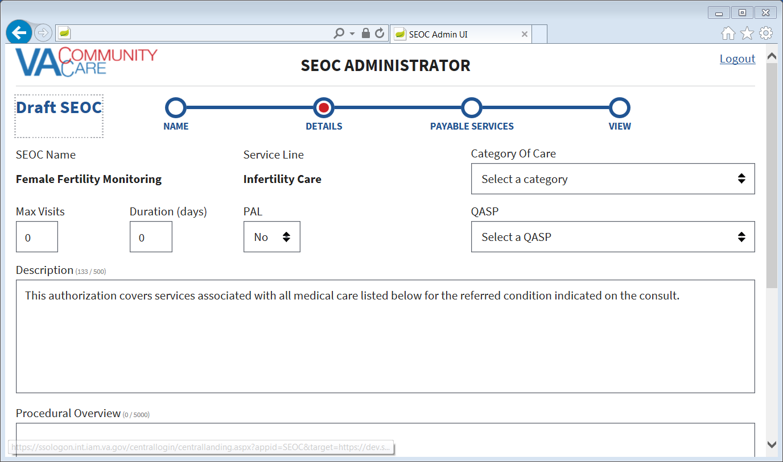

1. From the **Category of Care** drop-down menu, select the category.
2. In the **Max Visits** field, enter the maximum number of visits.
3. In the **Duration (days)** field, enter the duration.
4. From the **PAL** drop-down menu, select **Yes** or **No**.
5. From the **QASP** drop-down menu, select a QASP:

* **Complimentary & Integrative Health Care**
* **General Care**
* **General Dental Care**
* **Primary Care**
* **Specialty Dental Care**

1. In the **Description** field, enter a description for the procedure. The maximum amount of characters for this field is 500.
2. In the **Procedural Overview** field, enter an overview on the procedure. The maximum amount of characters for this field is 5000.
3. In the **Additional Information** field, enter additional information regarding the procedure. The maximum amount of characters for this field is 2000.
4. Click **Add/Edit Payable Services**. The **Draft SEOC: Payable Services** window displays.

Figure 14: Draft SEOC: Payable Services

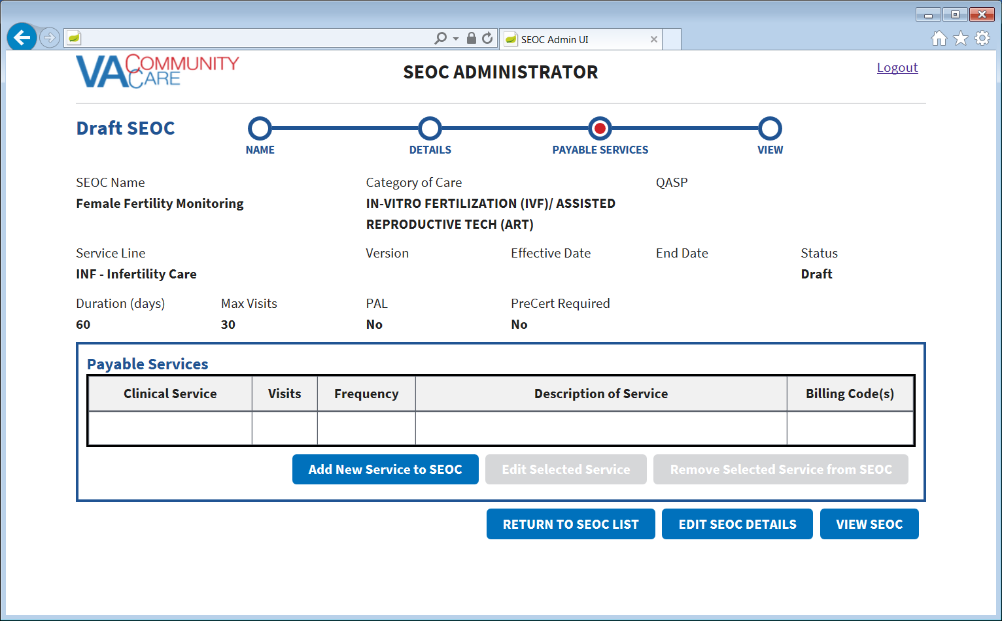

1. Click **Add New Service to SEOC**. The **Draft SEOC: Add Payable Service** section displays at the bottom of the page.

Figure 15: Draft SEOC: Add Payable Service

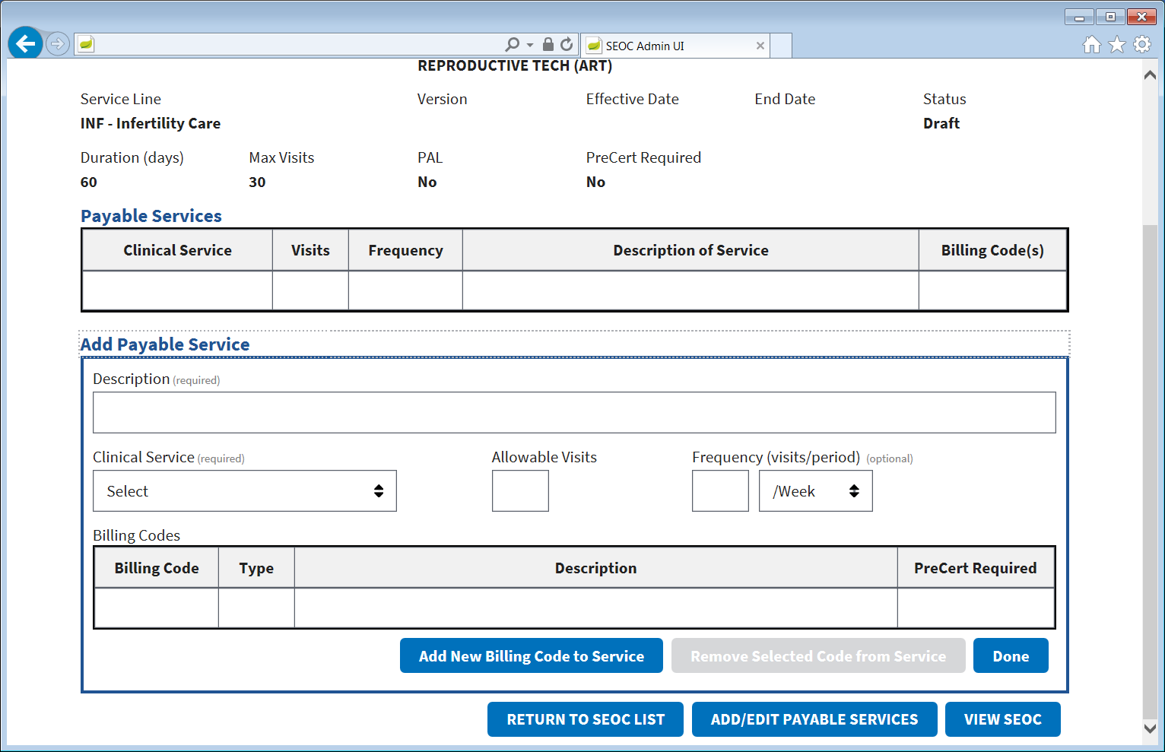

1. In the **Description** field, enter a description for the payable service (required field).
2. From the **Clinical Service** drop-down menu, select the type of service (required field).
3. In the **Allowable Visits** field, enter the number of allowed visits.
4. In the **Frequency (visits/period)** field, enter the number of visits and select if it is per week, month, or year (required field).
5. Click **Add New Billing Code to Service**. The **Draft SEOC: Add Billing Code** dialog box displays.

Figure 16: Draft SEOC: Add Billing Code

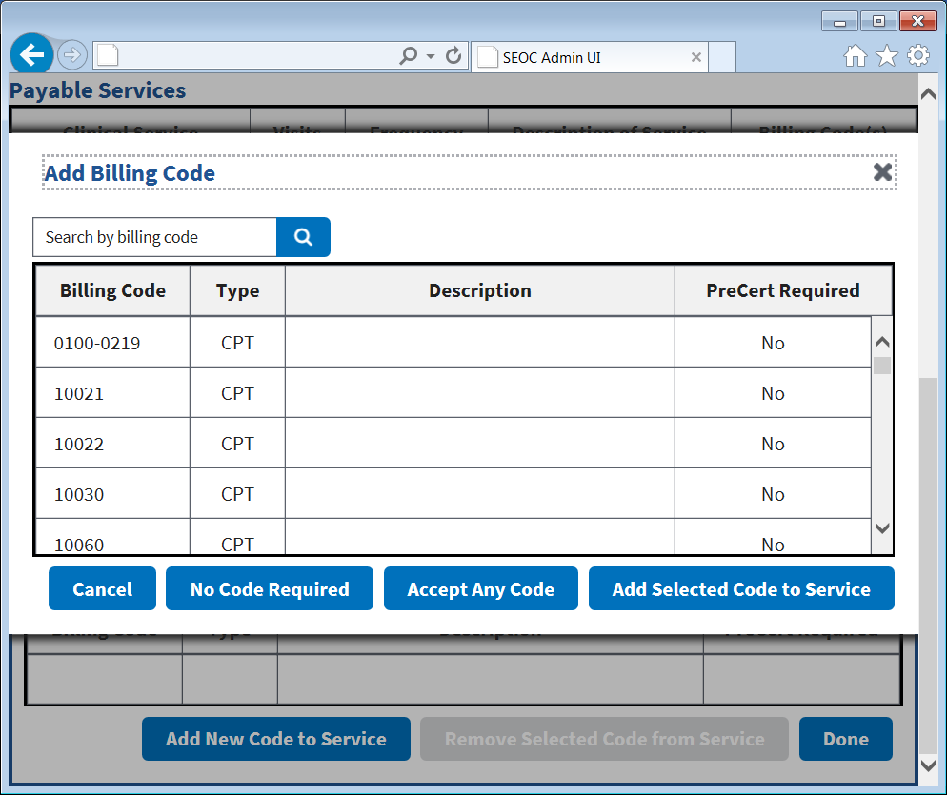

1. Select the billing code option for the Payable Service. If **No Code Requi**red is selected, the **PreCert Required** field defaults to **Yes**.
2. Click the **Add Selected Code to Service**. If you attempt to duplicate a billing code for the payable service, you will receive an error message.

Figure 17: Duplicate Billing Code Message



1. Click **Done**. The Payable Services will display.
2. Click **View SEOC**. The **Draft SEOC View** displays.

Figure 18: Draft SEOC View

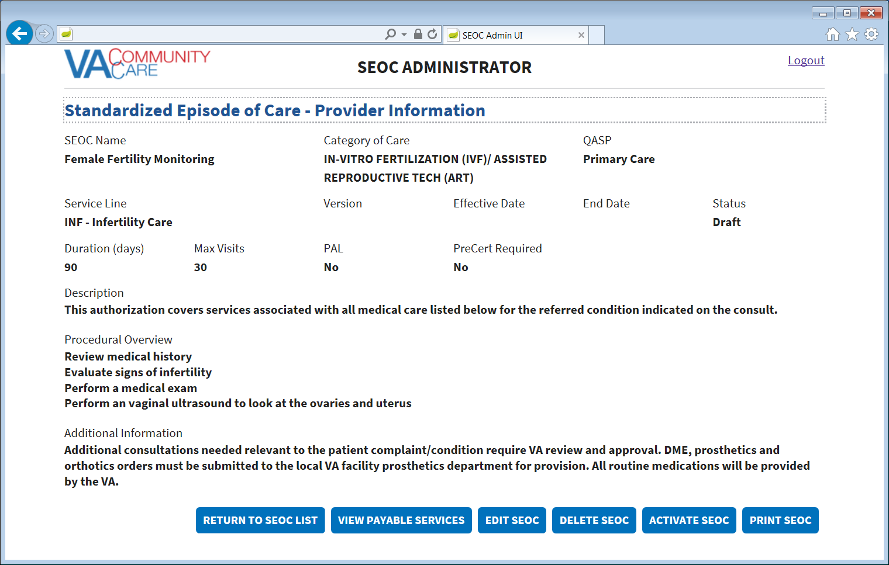

### Edit a Draft SEOC

1. If a user attempts to edit a SEOC that another user is already editing, the user will receive a message stating that the request can’t be processed.

To edit a draft SEOC, follow the steps listed below:

1. From the CC SEOC home page, select the draft SEOC you would like to edit.
2. Click **View Selected SE**OC, the **Standardized Episode of Care – Provider Information** page displays.
3. Click **EDIT SEOC**. The **Draft SEOC Name** window displays.
4. Edit the fields that need to be updated.
5. Click **View SEOC** to confirm the edits.

### Activate a Draft SEOC

To activate a draft SEOC, follow the steps listed below:

1. From the CC SEOC home page, select the draft SEOC you would like to activate.
2. Click **View Selected SE**OC, the **Standardized Episode of Care – Provider Information** page displays.
3. Click **Activate SEOC**. The **SEOC Activation Confirmation** dialog box displays.

Figure 19: SEOC Activation Confirmation

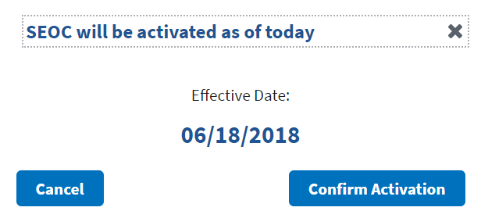

1. Click **Confirm Activation**. The status will update and display.

Figure 20: Activation Status

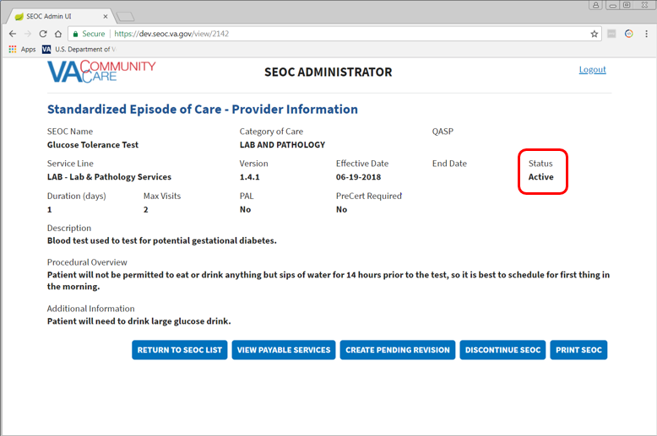

1. Click **Return to SEOC List** to see the activated SEOC in the list.

### Delete a Draft SEOC

To delete a Draft or Pending Revision SEOC, follow the steps listed below:

1. From the CC SEOC home page, select the draft SEOC you would like to delete.
2. Click **View Selected SE**OC, the **Standardized Episode of Care – Provider Information** page displays.
3. Click **Delete SEOC**. The Confirm Deletion dialog box displays.

Figure 21: Confirm Deletion



1. Click **Confirm Deletion**. The SEOC is deleted from the SEOC List.

## Pending Revisions

### Create a Pending Revision

To create a pending revision to an existing SEOC, follow the steps listed below:

1. From the CC SEOC home page, select the draft SEOC you would like to create a pending revision.
2. Click **View Selected SE**OC, the **Standardized Episode of Care – Provider Information** page displays.
3. Click **Create Pending Revision**. The **Pending Revision: Name** window displays.

Figure 22: Pending Revision: Name

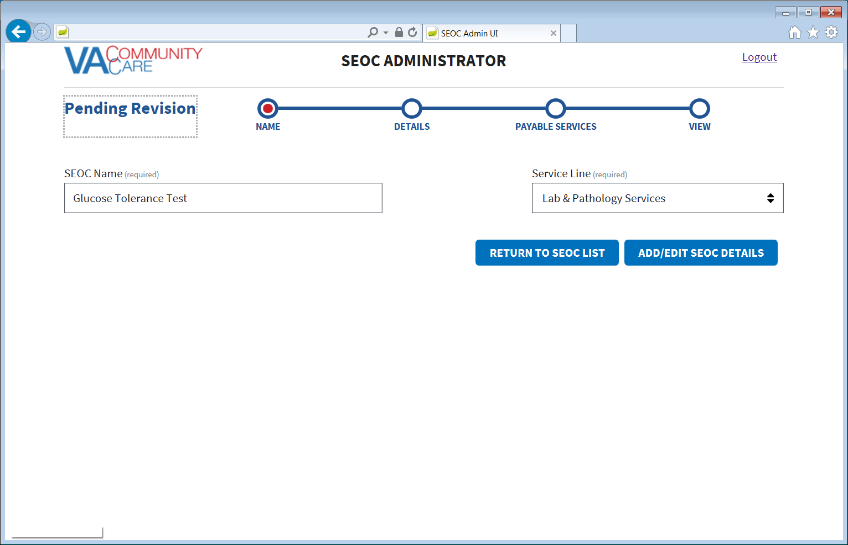

1. Update the SEOC name and service line as needed.
2. Click **Add/Edit SEOC Details**. The **Pending Revision: Details** window displays.

Figure 23: Pending Revision: Details

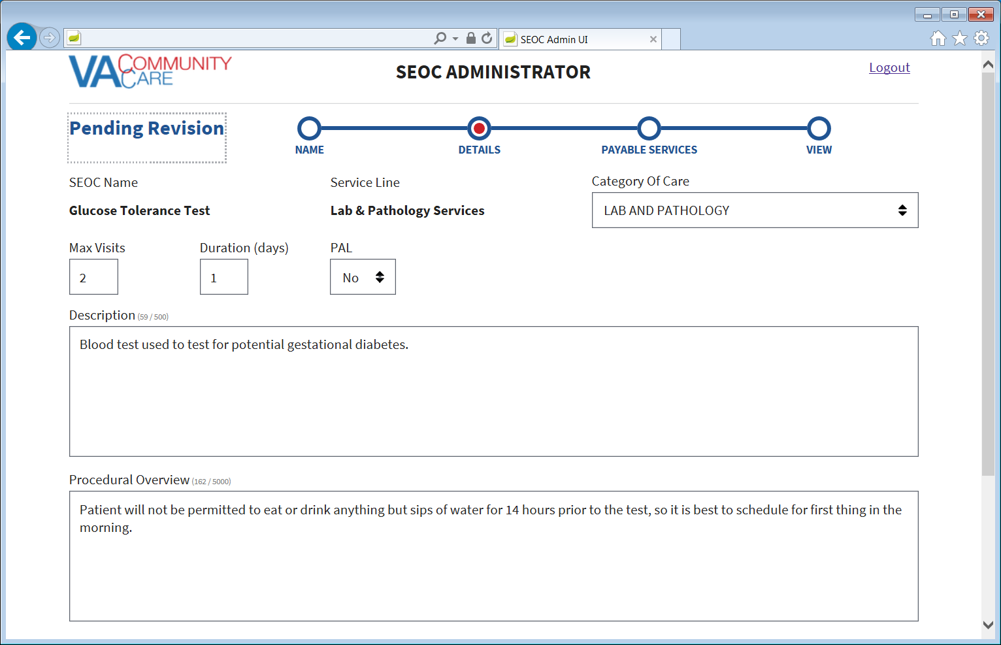

1. Update the details for the SEOC as needed.
2. Click **Add/Edit Payable Services**. The **Pending Revision: Payable Services** window displays.

Figure 24: Pending Revision: Payable Services

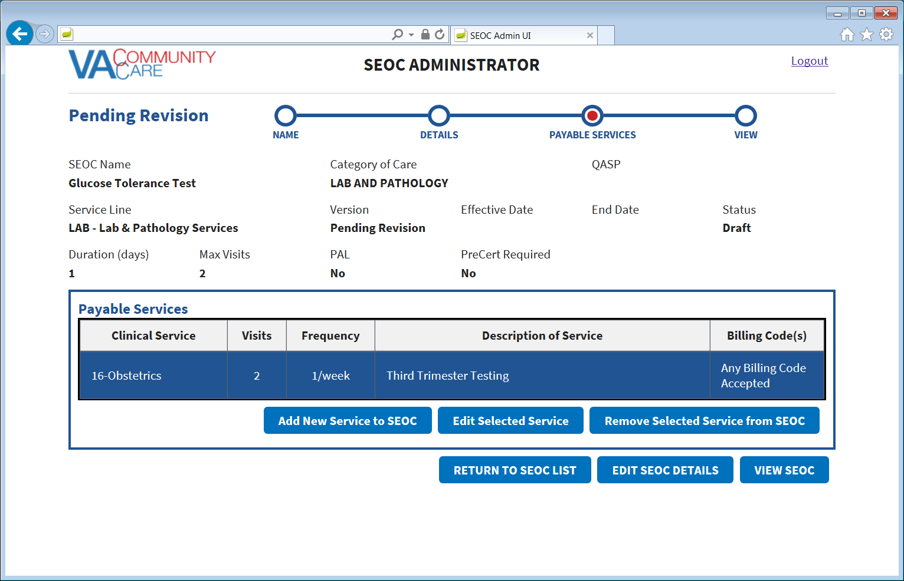

1. Update the Payable Services as needed.
2. Click **View SEOC**. The Pending Revision status will display in the window.

Figure 25: Pending Revision Status

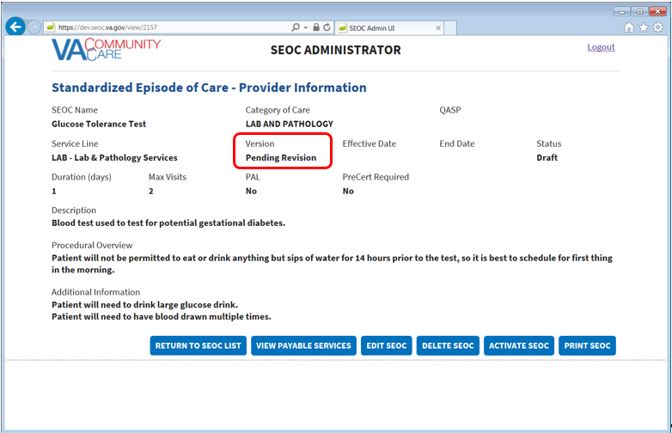

1. Click **Return to SEOC List**. The pending revision will display in the list of SEOCs.

Figure 26: Pending Revision Displayed in SEOC List

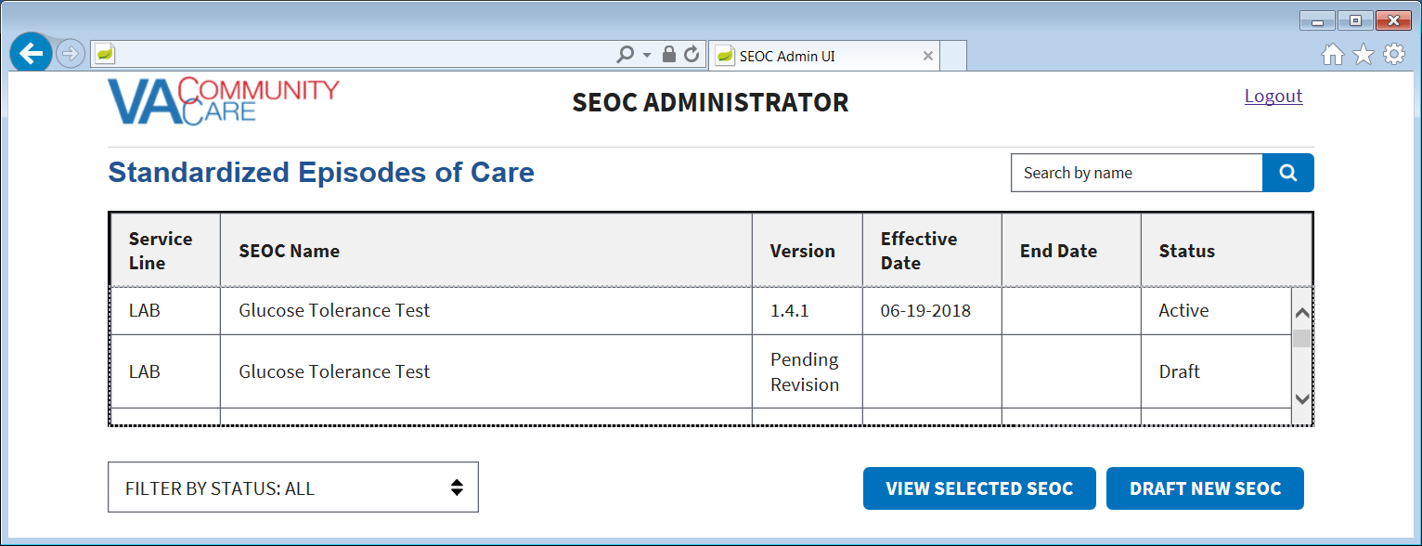

### Activate a Pending Revision

To activate a pending revision, follow the steps listed below:

1. From the CC SEOC home page, select the pending revision SEOC that you would like to activate.
2. Click **View Selected SE**OC, the **Standardized Episode of Care – Provider Information** page displays.
3. Click **Activate SEOC**.

Figure 27: Pending Revision Activation Confirmation Message

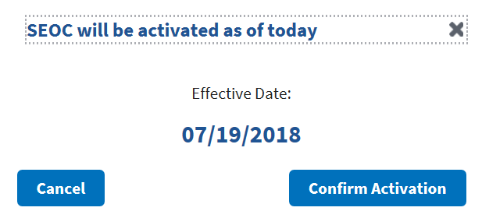

1. Click **Confirm Activation**. The Active Status will display in the new window.

Figure 28: Active Status

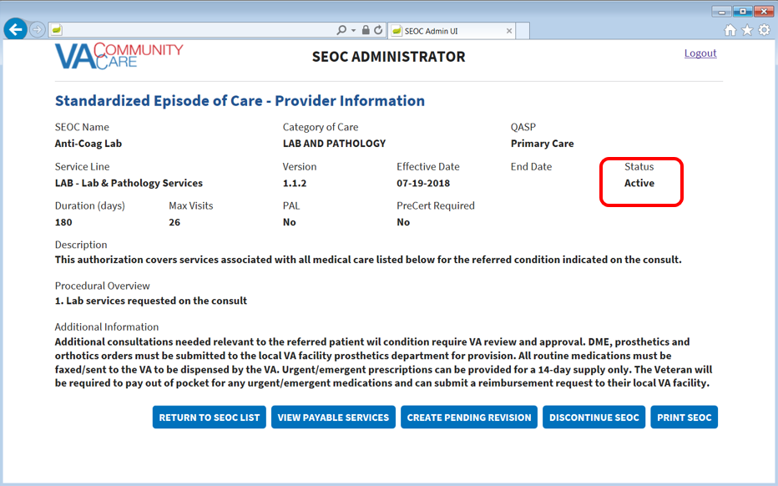

1. Click **Return to SEOC List**. The pending revision that you just activated will display as Active in the list of SEOCs.

## Payable Service List

### View Payable Services

To view the payable services for a selected SEOC, follow the steps listed below:

1. From the CC SEOC home page, select the SEOC you would like to view the payable services for.
2. Click **View Selected SE**OC, the **Standardized Episode of Care – Provider Information** page displays.
3. From the **Standardized Episode of Care – Provider Information** page, click the **View Payable Services** button. The **Standardized Episode of Care – Payable Services** page displays.

Figure 29: Standardized Episode of Care – Payable Services

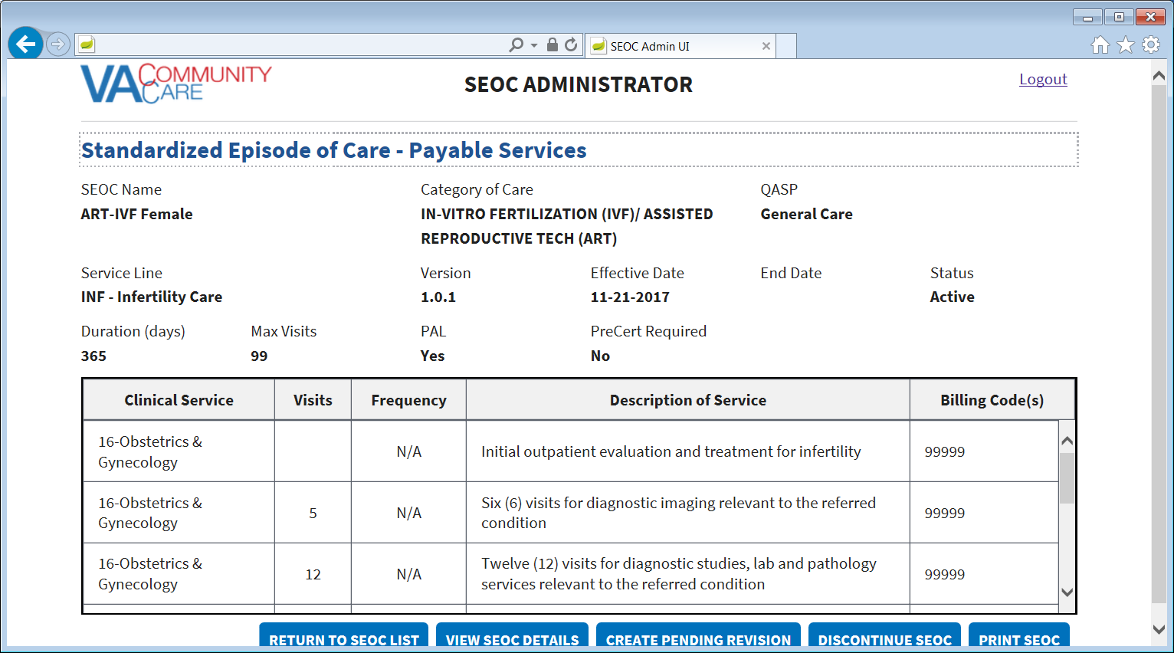

### Delete Payable Service

To delete payable services for a selected SEOC, follow the steps listed below:

1. From the CC SEOC home page, select the SEOC you would like to view the payable services for.
2. Click **View Selected SE**OC, the **Standardized Episode of Care – Provider Information** page displays.
3. From the **Standardized Episode of Care – Provider Information** page, click **Edit SEOC**. The **Draft SEOC Name** window displays.
4. Click **Add/Edit SEOC Details**. The **Draft SEOC Details** window displays.
5. Click **Add/Edit Payable Services**. The **Draft SEOC Payable Services** window displays.
6. From the list of payable services, select the payable service that you would like to delete.
7. Click **Remove Selected Service from SEOC**. A message will display confirming that you would like to delete the payable service from the SEOC.

Figure 30: Payable Service Confirm Deletion

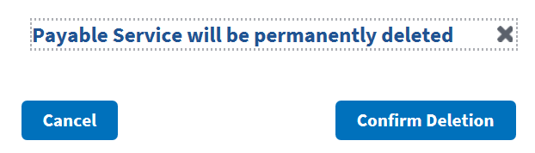

1. Click **Confirm Deletion**. The payable service is deleted from the list.

# Troubleshooting

Users may encounter the following errors while using the SEOC UI.

Table 2: SEOC Error Codes with Descriptions

| Error Code | Description |
| --- | --- |
| 204 | No Content Found |
| 401 | Unauthorized |
| 403 | Forbidden |
| 404 | Not Found |

# Acronyms and Abbreviations

| Acronym | Definition |
| --- | --- |
| CAC | Clinical Application Coordinators |
| CC | Care Coordination |
| CCAD | Community Care Agile Development |
| CDW | Corporate Data Warehouse |
| CID | Clinically Indicated Date |
| CPRS | Computerized Patient Record System |
| HEC | Health Eligibility Center |
| NSD | National Service Desk |
| OI&T | Office of Information and Technology |
| PCP | Primary Care Physician |
| SAR | Secondary Authorization Request |
| SEOC | Standardized Episode of Care |
| VA | Department of Veterans Affairs |
| VDL | VA Software Document Library |
| VistA | Veterans Health Information Systems and Technology Architecture |